Larkin’ Hill Arena Derby
Sunday April 23, 2023
Closing Date: Wednesday April 19th 9:00pm
North Chatham, NY

Arena Derby
A mixture of Stadium & XC jumps all set up in our large (230’ x 300’) outdoor sand arena!
NO WATCHES ALLOWED!!!

- A chance to get over some solid obstacles while the ground is still too soft for XC schooling!
- Classes ~ Intro, BN, Novice & Training
- Can enter as many rounds as you want, at any level!!!
- Scored on jump faults and closest to Optimum Time
- Ribbons 1st through 6th
- Add-on rounds allowed at the gate but you must be pre-entered for at least 1 round.

Class List: $40/Round
Class Test
#1 Intro – Jr Riders** Fences
#2 Intro – Open
#3 BN – Jr Riders**
#4 BN – Open
#5 Novice – Jr. Riders**
#6 Novice – Open
#7 Training – Jr. Riders**
#8 Training – Open
** Jr Riders are under 18 as of January 1st, 2024
Fence Heights:
Intro – 2’
BN – 2’7”
N – 2’11”
T – 3’3”

Rules for the Day:
- All horses must have proof of 12-month negative coggins (may be on file)
- All riders must wear a certified, protective helmet with attached harness/chin strap properly fastened at all times when mounted on the property.
- Any entries (including emailed entries) will be liable for payment once schedule has been posted.
- Extra jumping rounds may be added at the gate but must be pre-entered once.
- Cross Country vests are strongly encouraged but not required.
- Management reserves the right to refuse any entry for any reason.
- All classes run generally under USEA rules.
Stop, run out or rail at stadium fence = 4 faults
Stop or run out at XC fence = 20 faults
Fall at any level = Elimination
Time faults: 0.25 fault for every second over Optimum Time
Speed Faults: 0.25 fault for every second under Speed Fault Time
Directions and other information available on website – www.larkinhill.com
Questions? Call Margie at 518.441.2176 or email at mhutch5100@gmail.com

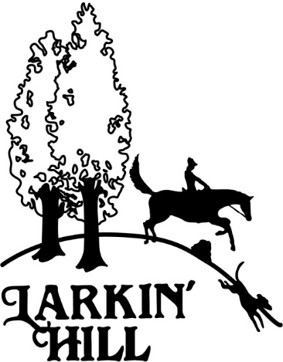
Entry Form
Make checks payable to: Larkin Hill
Mail to:
Margaret Hutchison / PO Box 300 / North Chatham, NY 12132
Email: mhutch5100@gmail.com
Phone: 518.441.2176
ENTRY & PAYMENT THROUGH WEBSITE PREFERRED

Rider’s Name:_____________________________________________________________
Address:__________________________________________________________________
Phone:_____________________________ Cell:__________________________________
Email:____________________________________________________________________
Horse’s Name:_____________________________________________________________
Classe(s):
__________ __________ __________ __________ __________
Total Fees: $_______________

I, the undersigned, agree to hold harmless all property owners, Larkin’ Hill, Margaret Hutchinson and any of the officers, officials and/or volunteers, and any and all employees of Larkin’ Hill, free from any claim of whatever nature that may be occasioned by me or any and all horses exhibited or controlled by me, and to repay the property owners on demand for any and all damages they may sustain by reason of any claim or demand occasioned as aforesaid. I further agree to wear appropriate protective headgear with chinstrap properly attached at any time while mounted on a horse on the show property.

__________________________________________________________________
Rider Signature

__________________________________________________________________
Signature of Parent or Guardian of any rider under 18 years of age

